|  |
| --- |
|  |
| Forecasting changes in consumption of the invasive Nile Perch with climate warming and subsequent changes in native fish populations |

Thesis for the completion of a degree in Honours Biology

Tristan Kosciuch

Department of Biology, McGill University

April 30, 2018

Supervisor:

Prof. Lauren Chapman

Forecasting changes in consumption of the invasive Nile Perch with climate warming and subsequent changes in native fish populations

Tristan Kosciuch, ID 260654384

**Abstract**

Climate change may lead to the increases in consumption of ectothermic organisms as metabolic demands increase with temperature. Here, I created a bioenergetic model for the invasive Nile perch to forecast how consumption of prey may change with warming waters. The Nile perch was introduced to the Lake Victoria basin and led to the extirpation of many native fishes, particularly ~40% of a highly diverse and endemic group known as the haplochromine cichlids. At the same time, the Nile perch has fueled what is now Africa’s largest inland fishery, leading to differences between economic and environmental interests. Modelling predicts that consumption of fish prey will increase more than consumption of invertebrates, and haplochromine cichlids will be the most heavily impacted fishes. However, growth rates of Nile perch are also predicted to increase, so the large fishery based upon the Nile perch could see an increase in productivity as a result. While the ecological consequences of climate change in the Lake Victoria basin are likely complex, increases in Nile perch prey consumption may be a driver of biodiversity loss as temperatures rise. Integrating sustainable fisheries management plans may help to alleviate these potential losses of biodiversity.

**Introduction**

There are many cases where the introduction of non-native predators into freshwater systems has had devastating consequences on the native fishes that serve as prey (Gozlan et al. 2010). Predicting the future of native fish communities in such systems depends, at least in part, on understanding the factors that affect the consumption dynamics of the introduced predator. Such factors could be adaptive change in the native prey (e.g., use of habitat refugia) (Chapman et al. 2002), fishing pressure on the predator (Daskalov et al. 2007), or more recently, climate warming and its associated effects on the bioenergetics of predator and prey (Rahel and Olden 2008). Forecasting the effects of climate warming on the predatory behaviour of invasive fishes is particularly important in the Lake Victoria basin of East Africa, where the introduction of the predatory Nile perch (*Lates niloticus*) has had major cascading effects on the native fish fauna (Balirwa et al. 2003).

Lake Victoria is the world’s largest freshwater tropical lake; and the lake and its basin directly support over 2 million people divided among three border countries: Kenya, Uganda, and Tanzania. The Lake also supports a $250 million dollar annual fish export market based largely around the Nile perch (NPFMP2, 2015), which was introduced to Lake Victoria and some surrounding lakes (Nabugabo, Kyoga) in the 1950s and 1960s (Ogutu‐Ohwayo 1993). While the introduction of the Nile perch has been an economic success, there have been serious ecological consequences. Lake Victoria is well known to the scientific community for harbouring 500+ species of haplochromine cichlids, a monophyletic clade of fishes that has undergone its radiation in the past 750,000 years (Greenwood 1974), although there is evidence for the radiation being much more recent (<150000 year old) (Verheyen et al. 2003). This example of rapid evolutionary differentiation is of great scientific value, but predation on haplochromines by the Nile perch contributed to the disappearance of ~40% of the species endemic to the lake (Witte et al. 1992, Seehausen et al. 1997). Similar patterns of species loss were observed in Lake Kyoga (a large lake north of Lake Victoria and part of the Nile River system) and Lake Nabugabo, a satellite lake of Victoria where the Nile perch was also introduced during the 1960s (Balirwa et al. 2003). However, the interaction between Nile perch and haplochromine cichlids is by no means static. Intense fishing pressure on the Nile perch has reduced its population size in lakes Victoria, Kyoga, and Nabugabo, reducing the predation pressure and allowing some haplochromine and other native species’ populations to rebound (Balirwa et al. 2003, Chapman et al. 2003, Paterson and Chapman 2009). There are other factors also at play that may affect the future of the Nile perch-native species interaction. One factor of note is warming waters associated with climate change, which may substantially alter certain trophic dynamics.

Under climate change, ectothermic organisms (like the Nile perch) may need to increase their rates of energy consumption. Ectothermic (cold blooded) organisms have their internal temperature regulated by the environment they live in, permitting changes in environmental temperatures to alter biological processes dependent upon temperature. Metabolic rate is one such process, and warming temperatures lead to increases in metabolic rates in the absence of adaptation or acclimatization (Brown et al. 2004). As metabolic demands increase, organisms must correspondingly increase their energy consumption or risk starvation. If the ecosystem is under strong top down trophic regulation predators (such as Lake Victoria is from the Nile perch), then changes in a top predator’s prey consumption driven by rising temperatures associated with climate change could affect the overall species community (Harley 2011). While bottom up effects such as increased ecosystem productivity are also possible under climate change, we can begin to explore climate warming’s potential effects using bioenergetic modelling. Bioenergetic modelling is a powerful tool that has a wide range of uses, from quantifying selection on juvenile salmonid growth rates (Myrvold and Kennedy 2015) to predicting biodiversity losses in mammals (Humphries et al. 2004). I used bioenergetics modelling to forecast how Nile perch predation will change under predicted climate scenarios. The Nile perch is an ectothermic predator and imposes strong top down trophic regulation on the aquatic community in the Lake Victoria basin, making any changes in its consumption rates likely to have strong cascading effects on the ecosystem it inhabits. I then integrate the bioenergetics model with Nile perch stomach content analysis, to see which species are being most heavily preyed upon, and to make predictions as to how those species may be impacted by changing Nile perch consumption under climate change.

**Methods**

To successfully make predictions as to how climate change will impact Nile perch predation and the Lake Victoria basin, three main aspects must be addressed: (1) quantification of the current Nile perch diet, (2) bioenergetic modeling to predict increases in Nile perch energetic demands, and (3) integration of the bioenergetic model with long term fish community data to predict how native fish populations will respond to changing Nile perch predation.

*Current Nile perch diet.* Nile perch diet was quantified through dissection of preserved (10% formalin) stomachs. Two sources of Nile perch stomachs were used, with all samples being from Lake Nabugabo, Uganda. The first source is from long-term fish sampling transects (long-term transects: LTT) which have been conducted during various periods between 1995 to present day. Because the majority of Nile perch caught in LTT were of small body size, full stomachs from large fish (>50 cm) were also purchased from local fishers. For this project, I used stomachs collected between 2015 and 2017 (n = 200). Stomachs from 2015/16 LTT were dissected in Uganda, while 2017 LTT and purchased stomachs were transported back to McGill for later analysis.

Stomachs were dissected following Schofield and Chapman (1999). Contents were identified to the lowest taxonomic category possible, counted, and weighed to the nearest 0.01 g. Dissection of stomachs was necessary to create an index of relative importance (IRI) for each prey item in the Nile perch diet. IRI was calculated as

$$Equation 1. IRI = [\%N +\%M]*\%F$$

where *%N* is relative abundance (number of times each food item is present as a percentage of all food items), *%M* is percent mass (mass of each type of food item expressed as the percent of total food item mass), and *%F* is frequency of occurrence (number of Nile perch containing each prey type, divided by the total number of non empty stomachs) (Hyslop 1980). IRI was first calculated for two prey categories, invertebrates and fish, by pooling all identified and unidentified prey into those categories. IRI for specific fish prey types was then recalculated excluding unidentified remains, and the resulting IRI was partitioned into the overall importance of fish in the Nile perch diet (as a percentage of total diet). IRI was calculated for different size classes of perch, as their prey preference switches from invertebrates to piscivory with growth (Nkalubo et al. 2014). The first size class was for perch 0-10 cm standard length (SL), with subsequent classes increasing by 5 cm (10-15 cm SL, etc.) up to a class composed of fish larger than 50 cm SL.

*Bioenergetic modelling.* Bioenergetic modelling uses an energy budget to predict an organism’s consumption of an energy source. The energy budget forms an equation composed of 3 basic parts:

$$Equation 2. Energy Consumed (consumption) = Respiration + Waste + Growth.$$

The three parameters comprising consumption are (1) Respiration: metabolic usage of energy in the organism’s daily routine, (2) Waste: energy lost as heat to the environment and the physical energy lost as excrement, and (3) Growth: energy assimilated as mass (Brett and Groves 1979). I used this basic concept to predict the total energy consumed by a 0.5 year old Nile perch (starting age) during 1 year of growth under different climate change scenarios. For this project, modelling was done in Fish Bioenergetics 3.0 (Hanson 1997) where the variables are broken down further to the equation:

|  |  |  |  |
| --- | --- | --- | --- |
| $$Equation 3. C = (R+A+S) + (F+U) + (ΔB+G)$$ | | | |
| *Consumption .* | *Respiration* | *Waste* | *Growth* |

Where abbreviations are defined as: energy consumption (C), resting respiration/metabolism (R), active metabolism (A), specific dynamic action (S), egestion (F), excretion (U), somatic growth (ΔB), and gonad production (G). Each of these seven main parameters is broken down further into functions relating changes in the value of the parameter defined to changes in either an organism’s mass, amount of food consumed (for F and U), or changes in environmental temperatures (Table S1.). Existing literature was then used to parameterize the respiration and growth components of the bioenergetic model, while Fish Bioenergetics 3.0 default values for Nile perch were used to model consumption and waste.

*Current and future environmental conditions*

In order to make accurate predictions as to how climate change will alter water temperatures in the Lake Victoria basin, current environmental information was needed. In Lake Nabugabo the LTT protocol involved taking water temperature measurements at each net set. Measurements were taken at the surface and every subsequent 0.5 meters until the bottom. By averaging all measurements taken on the Lake from 2015 to 2016, we were able to calculate an average temperature (Figure 1). Then using IPCC climate change predictions (Pachauri et al. 2014), future water temperatures were predicted. For the year 2100, regional predictions for climate warming forecasted a potential range of +1 ⁰C for low end climate warming to a +4 ºC temperature increase for high end climate warming. Using these predictions, a bioenergetics model was created for three different environmental temperatures: current (25.44 ⁰C), low end climate warming (26.44 ⁰C), and high end climate warming (29.44 ⁰C) to forecast changing consumption under the different possible climate change scenarios.

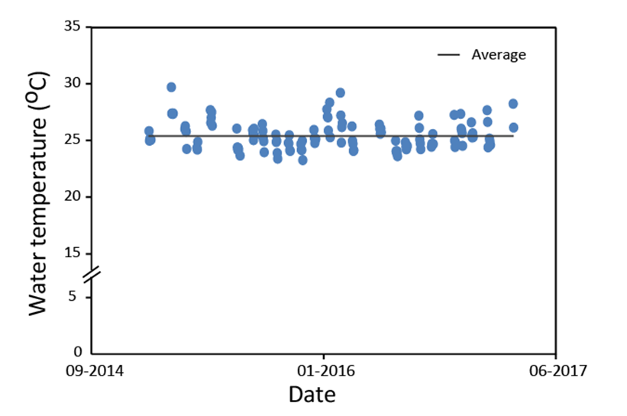

Figure 1. Average water temperature in lake Nabugabo from () to (). Within date variation represents measures made at multiple lake depths, although proportion of deep samples to shallow samples corresponds to average depth across sampling areas, so average temperature indicated should be a reasonable estimate of average water temperature in the lake. Data from LTT (Chapman, unpublished).

*Consumption*

While consumption was an output of the bioenergetic model, parameters describing the maximum possible rate of prey consumption (Cmax) and how this rate changed with growth and temperature were required (S1 Eq. S2 and S3, respectively). Cmax represents the amount of prey an organism could consume if it were unconstrained by requirements such as food availability and other ecological factors. Using the predicted Cmax the proportion (*p*) of Cmax that the Nile perch would need to feed at in order to achieve the growth predicted by the model was calculated. This was estimated by iteratively running the bioenergetics model using different *p* values until the final body mass of the simulated Nile perch matched the final body mass input to the model (see *Growth* section of methodology). This estimated *p* value was then used in a final bioenergetics run (see (Hanson 1997) for a more in depth analysis of *p* value calculation and usage). Parameters describing Cmax in Nile perch were kept as default values from Fish Bioenergetics 3.0 (Hanson 1997).

Changes in prey type consumed (accounting for changing prey preferences with body size/growth) were accounted for by an immediate switch to a new IRI size class. In other words, the prey preference of the simulated Nile perch did not slowly change with growth, the model suddenly changed diet preference when the simulated Nile perch reached a pre-set body mass. The exact value of this body mass was determined by the IRI size classes created for the stomach content analysis.

*Respiration*

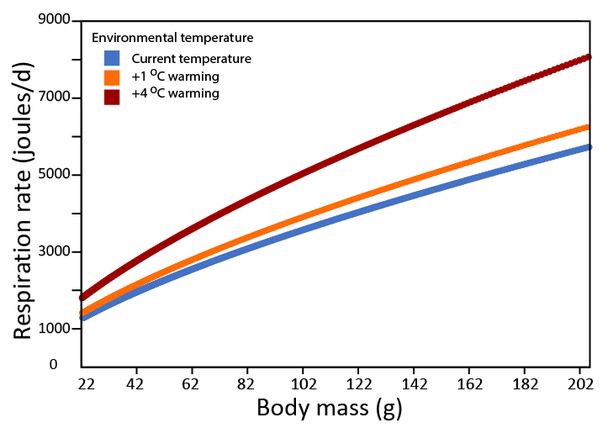 Respiration was modelled to depend on temperature and Nile perch body mass (Figure 2, Table S1 Eq. S8). The slope (RA) and intercept (RB) for the mass dependent function for standard metabolic rate (SMR), and the Q10 of SMR (RQ, Equation. 4), were determined using data from a three-week long acclimation of Nile perch to elevated temperatures published in Nyboer & Chapman, 2017. The mass dependent function for SMR was found using the slope and intercept of a linear regression of log transformed SMR values regressed upon body mass with acclimation temperature as a covariate. The slope of the acclimation temperature covariate (CS) and the high and low end acclimation temperatures (UT and LT, respectively) from Nyboer & Chapman, 2017 were used to calculate RQ according to the following equation:

Figure 2. Modelled respiration with changing body mass and temperature. Values are based off of output of bioenergetic model.

$$Equation 4. RQ={\left(\frac{e^{CS*UT}}{e^{CS*LT}}\right)}^{\frac{10}{UT-LT}}$$

All other respiratory parameters used in the model were unchanged from the default Nile perch settings in Fish Bioenergetics 3.0.

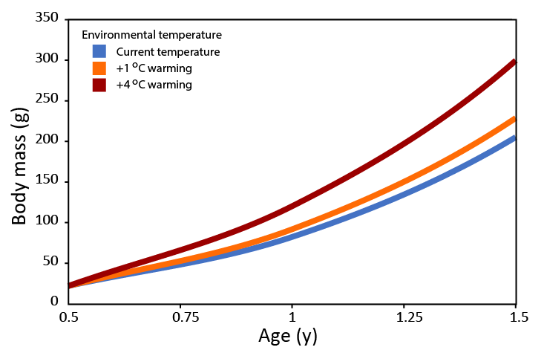*Growth*

To model growth in Fish Bioenergetics 3.0, the starting and ending weights of the simulated Nile perch are entered into the model. Unfortunately, a current estimate of the growth rate of Nile perch body mass in Lake Nabugabo was not available. In order to circumvent this, a length-age relationship of Nile perch from (Ndagire 2015) was combined with a length-weight relationship calculated from 2015 and 2016 LTT data (Chapman, unpublished), allowing for an Nile perch age-weight relationship to be established by setting lengths as equal (Equation 5). In the bioenergetic model, all fish began at the predicted mass of a 0.5 year old Nile perch in current environmental conditions.

Figure 3. Modelled changes in mass of Nile perch across 1 year of simulated growth under current environmental conditions and IPCC low (+1 ºC) and high (+4 ºC) end climate change predictions.

$$Equation 5. 11.434*{age}_{years}+4.5943=3.6752{\left({mass}_{grams}\right)}^{.3339}$$

In order to calculate how Nile perch growth might change under different climate change scenarios changes, growth rate data from Nyboer & Chapman (2017) were used. They acclimated Nile perch for three-weeks across a 4 ºC temperature increase, and found that fish raised in water raised 4 ºC above baseline environmental temperatures weighed 46% more than fish raised in unaltered water temperatures. This was used to calculate the change in growth rate across modelled temperatures, with growth of high end warming (+4 ºC) fish modelled to increase by 46%, and low end warming fish (+1 ºC) modelled to increase by 11.5% ($1℃*\frac{46\%}{4℃}$, Figure 3). Using data from Nyboer & Chapman (2017) to predict increasing growth rates came with some challenges, as fish in the study on average lost weight during the three week acclimation (with warmer acclimated fish losing less weight than colder acclimations). However, these fish were fed a limited ration, and as such the increase in growth rate observed with temperature, despite still being a negative rate, would possibly provide a conservative estimate of how much growth would increase from current rates if the Nile perch had an unlimited ration (as it may have in the wild, and as is assumed in the bioenergetic model). Fish fed unlimited rations typically show positive growth rates as well as increasing growth with temperature (Pauly 1980, Elliott 1982, Russell et al. 1996), and as such we felt justified to use the increase in growth among temperature treatments (i.e. the absolute difference between any two temperatures) found by Nyboer & Chapman (2017) to predict Nile perch growth rates under future climate change scenarios.

*Combining stomach content analysis and bioenergetic model.* The bioenergetics model created predicted total Joules of prey consumed across a year of growth, and in order to convert between joules of prey consumed and the more meaningful metric of mass, the energy density (joules/gram) of different prey items was used (Table 1). Prey energy density as well as IRI value was used to calculate the mass of different prey types consumed per day. This was done by multiplying the bioenergetic model’s prediction of energy consumption (joules) by the proportion of an individual prey item’s IRI value divided by the sum of all IRI, which gave the proportion of total amount (in joules) of each prey item consumed. The prey’s energy density was then used to convert joules consumed into grams consumed.

|  |  |  |  |
| --- | --- | --- | --- |
| Table 1. Energy densities of prey categories used in bioenergetic model. | | | |
|  |  |  |  |
| Prey type | Energy density | Source | |
|  |  |  | |
| Haplochromine cichlid | 5000 | (Kitchell et al. 1997) | |
| Nile perch | 5860 | (Kitchell et al. 1997) | |
| Other fishes | 5000 | (Kitchell et al. 1997) | |
| Invertebrates | 3176 | (Myrvold and Kennedy 2015) | |

**Results**

*Stomach content analysis*. A total of 200 full stomachs (39 purchased from fisherman, 161 from LTT) were analyzed and included in the report. Nile perch obtained from fisherman were on average larger (51.4 cm SL) than LTT perch (10.8 cm SL). Fish between 25 and 45cm were underrepresented in the study as they were rare in LTT samples but also too small to be captured by fisherman. No fish >40 cm SL included in the analysis was from LTT sampling, all were purchased from fisherman.

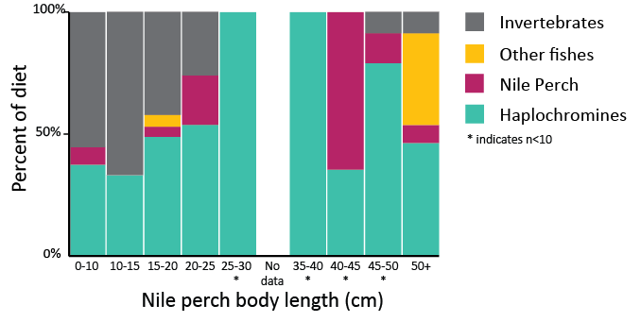

Figure 4. Distribution of percentage of total IRI for different prey items across Nile perch body length (standard length, cm). Size classes 25-50 cm (*) had sample sizes <10.

Overall, fish <15 cm SL had over 50% (% IRI) of their diet composed of invertebrate prey while fish >25 cm SL switched entirely to piscivory (invertebrate remains found in fish >45 cm SL were likely present due to having been fed upon by Nile perch prey.) (Figure 4). This result agrees with previous stomach content analysis performed on Nile perch captured in 2007 (Paterson and Chapman 2009) but is in contrast to previous sampling from 2000 and 1995, which found the shift to piscivory occurred at a much larger size class, likely due to the fact that fish prey, especially haplochromine cichlids, were less abundant in those years (Schofield and Chapman 1999, Chapman et al. 2003)

The invertebrates found in Nile perch stomachs were (in order of abundance by mass) *Povilla* (burrowing mayfly) larvae, chironomid larvae, chironomid pupae, Odonata nymphs, and unidentified invertebrates. Haplochromine cichlids were overall the dominant fish type preyed upon, followed by Nile perch, unidentified fish remains, and then various other species. Other species were comprised of (in order of abundance by mass) *Mastacembelus* eels, *Clarias* catfish, *Barbus magdalenae*, tilapiine cichlids, and *Rastrineobola argentea* (Table S4). While the %IRI for total fish consumed of haplochromine and Nile perch prey found in stomachs remained relatively constant across body sizes (IRI for total fish consumption; Haplochromine: 94.8% ± 5.7% SD, Nile perch: 3.8% ± 5.1%), Nile perch >50 cm had significantly (Grubb’s test, significant outlier P<0.01) a great proportion of fish prey that were not Nile perch or haplochromines than the other size classes.

*Bioenergetics model*. The model predicted that under current environmental temperatures, haplochromine cichlids and invertebrate prey were approximately equal in importance in the Nile perch diet, and together comprised ~91% of the of the food consumed by a 0.5 year old Nile perch during one year of growth (Figure 5). With climate warming, and under temperatures predicted by the IPCC climate model RCP2.6 (low end year 2100 climate prediction, +1ºC) the model predicted a 12% increase in Nile perch prey consumption. Under IPCC RCP8.5 (high end year 2100 climate prediction, +4ºC) Nile perch consumption was predicted to increase by 52%. Increases in consumption were not equal across prey types. Haplochromine cichlids saw the largest increase in terms of grams of prey consumed, with consumption rising 14 and 61% under low and high end climate change predictions, respectively. Invertebrates were the second heaviest hit prey group, with consumption rising 8 and 32% under low and high end climate change predictions, respectively. Consumption of Nile perch (cannibalism) was predicted to increase by 154%, but overall consumption in terms of grams consumed of Nile perch remained minor compared to consumption of haplochromine cichlids or invertebrates (Figure 5).

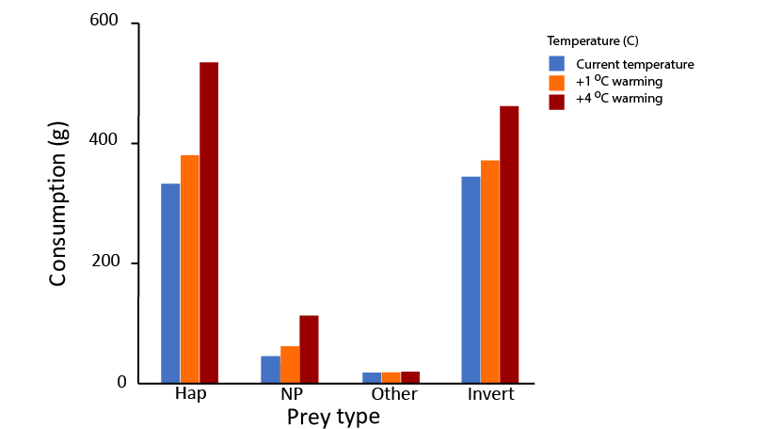

Figure 5. Increases in Nile perch prey consumption predicted by the bioenergetics model under IPCC low end (+ 1ºC) and high end (+ 4ºC) climate warming. Prey categories are haplochromine cichlids (Hap), Nile perch (NP), various other fishes (Other), and invertebrates (Invert).

**Discussion**

The implication that climate change will exacerbate the loss of biodiversity in the Lake Victoria basin caused by the introduced Nile perch is supported by our bioenergetic modelling. Particularly at risk are the species of haplochromine cichlids that are of high conservation value due to their diversity and endemism. The model was run using diet data taken from perch at a time when haplochromine cichlids were relatively abundant in Lake Nabugabo. As such, it was expected (and found) that haplochromines would feature heavily in the Nile perch diet. However, there is also evidence to suggest that Nile perch will preferentially feed on haplochromines even if other viable prey is available.

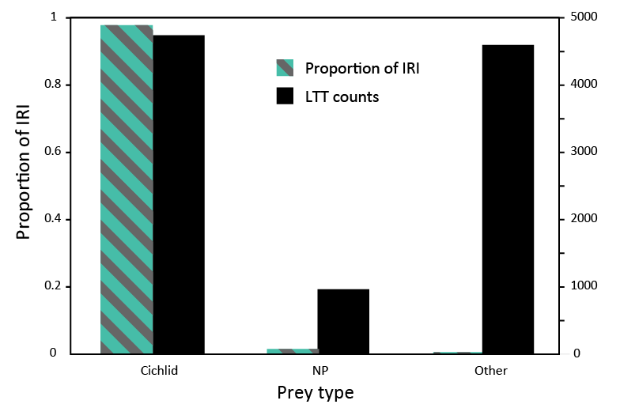

Figure 6. Proportion of importance (%IRI) of different fishes to Nile perch diet pooled for all Nile perch body sizes, in comparison to the relative abundance of those fishes in Lake Nabugabo. Other represents other species of fish, and was largely comprises of Brycinus sadleri. Data from long term transects (LTT, Chapman, LJ unpublished) performed during 2015 and 2016, and total counts of different prey items caught across sampling period are given.

Unpublished data from the Chapman lab indicates that in 2015 and 2016, there was an abundance of *Brycinus* *sadleri* in Lake Nabugabo, with population numbers rivaling the abundance of the haplochromine cichlids. *B. sadleri* in theory appear to be a viable prey for Nile perch, yet were dramatically underrepresented in Nile perch stomachs compared to their abundance in the lake (Figure 6, 7). There is also preliminary unpublished data to suggest that both *Rastrineobola argentea* and *Barbus magdalenae* are fairly abundant in Lake Nabugabo. *R. argentea* are known to be preyed upon by Nile perch in certain circumstances, but were largely absent in Nile perch stomachs analyzed. *Barbus magdalenae*, while a potential prey species for Nile perch, was also rare in Nile perch stomachs. These results suggest that Nile perch preferentially feed upon haplochromine cichlids and may only switch prey sources when haplochromine populations are depleted, results that support the findings of (Chapman et al. 2003) and (Paterson and Chapman 2009). This also implies that the large increase in haplochromine consumption predicted by the model under climate change may be sustained until haplochromine populations are depleted, further increasing biodiversity loss.

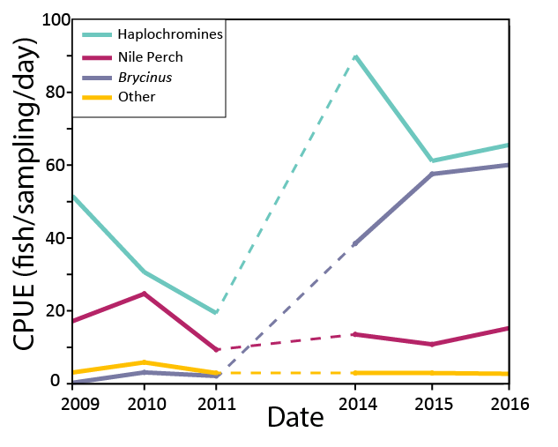

Figure 7. Changes in fish community in Lake Nabugabo. Other represents various other species of fishes such as Clarias and Petrocephalus spp. but notably underestimates Rastrineobola argentea and Barbus magdalenae, which are relatively abundant in the lake but are too small to be captured by the gill nets used. Data from Chapman, unpublished.

While the results of the model are important to biodiversity conservation efforts, there are implications for fisheries management as well, and the both economic and environmental interests should be accounted for when designing future Nile perch management plans. However, there are a few possible different scenarios as to how climate change will affect the Nile perch and in order to preserve both biodiversity and the fishing industry, these need to be accounted for. With increasing water temperatures, Nile perch could respond in a number of different scenarios. 1. As metabolic demand for food increases, Nile perch could increase consumption of prey items, i.e. the scenario proposed by the model. 2. The functional response of Nile perch may be such that it is unable to consume food at a rate required to sustain its increasing metabolic demands, and the average condition factor or growth rate of fish may decrease. 3. Nile perch may be able to acclimatize or adapt to long term increases in temperatures, and metabolic demands may not increase significantly under climate change. There is evidence that Nile perch are able to metabolically acclimate to changes in temperature. Nyboer & Chapman 2017 also performed short term acclimations (3 days) of Nile perch to a broad range of temperatures. Comparisons between 3 day and 3 week acclimations showed that for the same treatment temperature (aside from baseline no temperature increase) the SMR of 3 week acclimated Nile perch was lower than the 3 day acclimation group, indication some ability for Nile perch to compensate to increases in their environmental temperature. It remains to be seen if Nile perch would be able to further compensate given longer acclimation times (see Future work). Each of these three scenarios has different implications for both the production of the Nile perch fishery and the preservation of local biodiversity.

The first scenario, where Nile perch increase their consumption of prey in response in climate warming/increasing metabolic demands, is the one implied in the bioenergetics model created and forecasts the largest impact on local biodiversity. While the other ecological changes in the Lake Victoria basin levied through climate change may be difficult to predict, under this scenario it is reasonable to forecast that the fish community revert towards conditions found during periods of high Nile perch abundance (i.e. during the 1980s (Witte et al. 1992)). During this time, native biodiversity declined dramatically, and the food web of Lake Victoria was restructured to be dominated by Nile perch, *Rastrineobola argentea* and an introduced tilapiine cichlid *Oreochromis niloticus* (Nile tilapia) with haplochromine cichlids and other natives showing severe population declines. While the exact nature of any ecological changes under this (and the other scenarios) is difficult to predict, simplification of the food web and an overall loss of biodiversity was what occurred previously in the Lake Victoria basin as predation by Nile perch increased (Balirwa et al. 2003).

While this first scenario may pose a challenge to biodiversity preservation, it may conversely lead to an increase in productivity in the Nile perch fishery. As metabolic processes and food consumption increase with temperature, so should growth rate (Brown et al. 2004). Increases in Nile perch growth rate under climate change (as is predicted by this bioenergetic model) could lead to increased productivity in ways analogous to the increases seen in modern agriculture from the selection or genetic modification used to increase the growth rates of crops and livestock (Zuidhof et al. 2014). In this regard, sustainable increases in Nile perch harvesting may be possible and may also help ameliorate potential losses of biodiversity from increases in Nile perch prey consumption (Balirwa et al. 2003).

Scenarios 2 and 3 represent slightly different implications for both biodiversity preservation and fisheries management. If Nile perch predation is not able to increase at a rate conducive to the increases in metabolic demands (scenario 2), then solely due to this disconnect between metabolic demands and prey consumption, fisheries production should decrease with increasing water temperatures. Alternatively, if Nile perch are able to acclimate/adapt to increases in temperature, they may not experience any significant increases in metabolic demands, and as such their predation rates may not increase under climate warming. Fishes in general demonstrate some acclimation response when reared under warmer temperatures (Brown et al. 2004) yet there is still a relationship between environmental temperature and metabolic rate in natural populations of fishes (Clarke and Johnston 1999), suggesting that perfect acclimatization or adaptation in increases in environmental temperature may not occur if temperature changes are extreme enough.

Other bioenergetics models have been produced for similar species, and find varying support for the different hypothesis listed above. (Rice et al. 1983) found that in populations of largemouth bass, consumption of prey likely remained similar despite differences in thermal regimes. What resulted was fish in warmer waters lost weight relative to fish in cooler waters (scenario 2). (Kishi et al. 2010) used predicted increases in prey abundance with climate warming to forecast increases in growth of chum salmon, but did not consider changes in feeding rates that were not linked to changes in prey abundance. (Petersen and Kitchell 2001) and (Breeggemann et al. 2016) predicted increasing consumption with climate warming but also predicted some possible decreases in growth rates if predation could not accommodate increasing metabolic demands, and uncertainty still existed as to how flexible rates of consumption were in the actual populations of fish. This illustrates a difficult barrier between linking bioenergetic predictions to actual changes in consumption, changing prey consumption in the wild may be a complex of a response to changes in temperature, and laboratory experiments may not represent wild conditions accurately enough. Numerous examples of increased feeding rates under elevated temperatures exist for organisms, but most were kept under laboratory conditions (Englund et al. 2011, Oyugi et al. 2012, Frances and McCauley 2018). However, wild fish may already be feeding at ecologically imposed maximum consumption rates, and further increases in consumption may not be energetically beneficial (if prey availability is too low) or otherwise decrease fitness (Englund et al. 2011). Nevertheless, the trend towards increasing rates of consumption with temperature in laboratory experiments suggest that wild populations of fish may tend to do the same.

**Future work**

Numerous experiments could provide data that would improve the current model, but two in particular may provide the most useful information. First and foremost, a longer acclimation experiment of Nile perch to elevated temperatures would give a better indication as to how acclimatization may ameliorate the potential affects of climate change on Nile perch metabolic processes. Results from a three-month long Nile perch acclimation experiment performed by Nyboer and Chapman are currently being analyzed (by Nyboer and Chapman) and will be incorporated into the model when available. Second, empirical evaluation of the functional response of Nile perch would also significantly improve the model. Understanding how the functional response changes with temperature, especially in wild populations of Nile perch, may provide insights as to if consumption of prey may actually be able support any increases in metabolic demands due to climate warming. These two experiments should help determine which of the three scenarios (or combinations of scenarios) listed will be the most likely to occur under climate change.

Various permutations of the bioenergetic model could also be created, notably to account for changes in fishing pressure. Kitchell et al. 1997 used bioenergetic modelling to predict ecological impacts of different Nile perch fishing strategies (gill nets, beach seines, etc.). One possibility would be to combine different fishing scenarios (outlined in (Kitchell et al. 1997)) with predictions for climate change, in order to understand how climate warming and fisheries management may interact.

Finally, Lake Nabugabo (the model system of Lake Victoria used for this project) has been the subject of long term sampling efforts (LTT, described in methodology and (Paterson and Chapman 2009)) giving relative abundances of the different fishes in Lake Nabugabo over time, and trophic interactions between the Nile perch and native species may potentially be quantified from the time series using a linear autoregressive model. This trophic interaction could be updated with the predicted increase in Nile perch consumption (from bioenergetic modelling) to have a quantified estimate of the future trophic interactions between Nile perch and its prey.

**Conclusions**

Under climate warming, consumption of prey by Nile perch may increase. Modelling suggests that consumption of fish prey will increase more than consumption of invertebrates. In the Lake Victoria basin, this increase in consumption is likely to most heavily impact the highly diverse group of haplochromine cichlids. However, growth rates of Nile perch are also predicted to increase, and the large fishery based upon the Nile perch could see an increase in productivity as a result. While the ecological consequences of climate change in the Lake Victoria basin are likely complex, increases in Nile perch prey consumption may be a driver of biodiversity loss as temperatures rise.

**Acknowledgements**: The endless support from L. Chapman, combined with critiques from the Chapman lab (notably David Hunt and Shelby Clarke) helped make this thesis possible. Much support in Uganda was received, and thanks to Jude the fishmonger, Mutebi, Kibaru, Sseguya, and Dennis Twinomugisha for help in the field. Charlotte Senechal, Kiran Yendamuri, Mikhaela Neelin and others helped to enter LTT data, and their work was greatly appreciated. And thank you to the friends and family I have at home, at McGill, and around the world, its been quite the adventure and your support throughout has been appreciated.

**Supplemental material**

|  |  |  |  |  |
| --- | --- | --- | --- | --- |
| Table S1. Equations used to build bioenergetic model. Parameter values given in Table S2. | | | | |
|  | | | | |
| Equation number | | | Equation | Description |
| Consumption | | |  |  |
|  | Eq. S1 | $$C=C_{max}*p*f_{C}(T)$$ | | Consumption (C) as a percentage (*p*) of Cmax and dependent upon temperature (*f*C(*T*)) |
|  | Eq. S2 | $$C_{max}=CA*W^{CB}$$ | | Maximum feeding rate of Nile perch based of body mass (W) |
|  | Eq. S3 | $$f_{C}\left(T\right)={VC}^{XC}*e^{(XC*(1-VC)}$$ | | Temperature dependent feeding rate |
|  | Eq. S4 | $$VC=\frac{(CTM-T)}{(CTM-CTO)}$$ | |  |
|  | Eq. S5 | $$XC=\frac{{ZC}^{2}*{\left(1+\sqrt{1+\frac{40}{YC}}\right)}^{2}}{400}$$ | |  |
|  | Eq. S6 | $$ZC=\ln{(CQ)}*(CTM-CTO)$$ | |  |
|  | Eq. S7 | $$YC=\ln{(CQ)}*(CTM-CTO+2)$$ | |  |
| Waste | | |  |  |
|  | Eq. S8 | $$R=RA*W^{RB}*f_{R}(T)*ACT$$ | | Respiration as a function of body mass (W), temperature (*f*R(T)), and Activity respiration multiplier (ACT) |
|  | Eq. S9 | $$S=SDA*(C-F)$$ | | Proportion of energy lost to specific dynamic action (SDA) |
|  | Eq. S10 | $$f_{R}\left(T\right)={VR}^{XR}*e^{(XR*(1-VR)}$$ | | Temperature dependent respiration rate |
|  | Eq. S11 | $$VR=\frac{(RTM-T)}{(RTM-RTO)}$$ | |  |
|  | Eq. S12 | $$XR=\frac{{ZR}^{2}*{\left(1+\sqrt{1+\frac{40}{YR}}\right)}^{2}}{400}$$ | |  |
|  | Eq. S13 | $$ZR=\ln{(RQ)}*(RTM-RTO)$$ | |  |
|  | Eq. S14 | $$YR=\ln{(RQ)}*(RTM-RTO+2)$$ | |  |
| Waste | | |  |  |
|  | Eq. S15 | $$F = FA*C$$ | | Egestion rate |
|  | Eq. S16 | $$U = UA * (C-F)$$ | | Excretion rate |
| Growth | | |  |  |
|  | Eq. S17 | $$SL=LA*W^{LB}$$ | | Standard length of Nile perch as a function of body mass |
|  | Eq. S18 | $$SL=YB*age\left(years\right)+YA$$ | | Standard length of Nile perch as a function of age |

|  |  |  |  |  |  |
| --- | --- | --- | --- | --- | --- |
| Table S2. Bioenergetic parameters used in modelling (equations from Table S1). | | | | | |
|  | | |  |  |  |
| Symbol | | | Parameter description | Value | Source |
| Consumption | | |  |  |  |
|  | CA | Intercept for maximum consumption | | 0.3 | (Kitchell et al. unpublished) |
|  | CB | Slope for maximum consumption | | -0.27 | (Kitchell et al. unpublished) |
|  | CQ | Slope (Q10) of temperature dependence | | 2.65 | (Kitchell et al. unpublished) |
|  | CTO | Optimal temperature for maximum consumption | | 27.5 | (Kitchell et al. unpublished) |
|  | CTM | Maximum temperature for maximum consumption | | 38 | (Kitchell et al. unpublished) |
| Respiration | | |  |  |  |
|  | RA | Intercept for standard respiration | | 0.013 | (Nyboer and Chapman 2017) |
|  | RB | Slope for standard respiration | | -0.326 | (Nyboer and Chapman 2017) |
|  | RQ | Slope (Q10) for temperature dependence | | 2.3159 | (Nyboer and Chapman 2017) |
|  | RTO | Optimal temperature for standard respiration | | 38 | (Kitchell et al. unpublished) |
|  | RTM | Maximum temperature for standard respiration | | 43 | (Kitchell et al. unpublished) |
|  | ACT | Activity respiration multiplier | | 2 | (Kitchell et al. unpublished) |
|  | SDA | Specific dynamic action coefficient | | 0.163 | (Kitchell et al. unpublished) |
| Waste | | |  |  |  |
|  | FA | Egestion loss coefficient | | 0.104 | (Kitchell et al. unpublished) |
|  | UA | Excretion loss coefficient | | 0.068 | (Kitchell et al. unpublished) |
| Growth | | |  |  |  |
|  | LA | Intercept of Nile perch length-weight relationship | | 3.6752 | LTT, Chapman unpublished |
|  | LB | Slope of Nile perch length-weight relationship | | 0.3339 | LTT, Chapman unpublished |
|  | YA | Intercept of Nile perch length-age relationship | | 4.5943 | (Ndagire 2015) |
|  | YB | Intercept of Nile perch length-age relationship | | 11.434 | (Ndagire 2015) |
|  |  |  | |  |  |
|  | | | | | |

|  |  |  |  |  |  |  |  |  |  |
| --- | --- | --- | --- | --- | --- | --- | --- | --- | --- |
| Table S3. Bioenergetic predictions of grams and percentage of total consumption by prey type for Nile perch under different climate change scenarios (low and high end climate warming). | | | | | | | | | |
|  | | | | | | | | |  |
|  | Prey type: | | | Grams consumed | | |  | |  |
| % of diet | | |  | |  |
|  | | | | | | | | |  |
| Temperature | Cichlid | NP | Other fish | | Total fish | Total invert | | Total  (g) | | |
| Current | 332.44 | 44.86 | 18.15 | | 395.45 | 344.46 | | 739.91 | | |
| 45% | 6% | 2% | | 53% | 47% | |
| Low end (+1 ºC) | 379.82 | 61.23 | 18.30 | | 459.36 | 371.46 | | 830.82 | | |
| 46% | 7% | 2% | | 55% | 45% | |
| High end (+4 ⁰C) | 534.98 | 112.68 | 19.67 | | 667.33 | 462.04 | | 1129.37 | | |
| 47% | 10% | 2% | | 59% | 41% | |
|  |  | | | | | | | | |

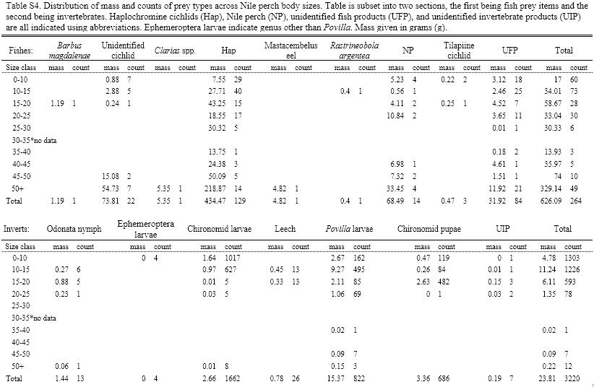

**References**

2015. NPFMP2, 2015-2019, April 2015. Indian Ocean Commission.

Balirwa, J. S., C. A. Chapman, L. J. Chapman, I. G. Cowx, K. Geheb, L. Kaufman, R. H. Lowe-McConnell, O. Seehausen, J. H. Wanink, and R. L. Welcomme. 2003. Biodiversity and fishery sustainability in the Lake Victoria basin: an unexpected marriage? BioScience **53**:703-716.

Breeggemann, J. J., M. A. Kaemingk, T. J. DeBates, C. P. Paukert, J. R. Krause, A. P. Letvin, T. M. Stevens, D. W. Willis, and S. R. Chipps. 2016. Potential direct and indirect effects of climate change on a shallow natural lake fish assemblage. Ecology of Freshwater Fish **25**:487-499.

Brett, J., and T. Groves. 1979. Physiological energetics. Fish physiology **8**:280-352.

Brown, J. H., J. F. Gillooly, A. P. Allen, V. M. Savage, and G. B. West. 2004. Toward a metabolic theory of ecology. Ecology **85**:1771-1789.

Chapman, L. J., C. A. Chapman, F. G. Nordlie, and A. E. Rosenberger. 2002. Physiological refugia: swamps, hypoxia tolerance and maintenance of fish diversity in the Lake Victoria region. Comparative Biochemistry and Physiology Part A: Molecular & Integrative Physiology **133**:421-437.

Chapman, L. J., C. A. Chapman, P. J. Schofield, J. P. Olowo, L. Kaufman, O. Seehausen, and R. Ogutu‐Ohwayo. 2003. Fish faunal resurgence in Lake Nabugabo, East Africa. Conservation Biology **17**:500-511.

Clarke, A., and N. M. Johnston. 1999. Scaling of metabolic rate with body mass and temperature in teleost fish. Journal of animal ecology **68**:893-905.

Daskalov, G. M., A. N. Grishin, S. Rodionov, and V. Mihneva. 2007. Trophic cascades triggered by overfishing reveal possible mechanisms of ecosystem regime shifts. Proceedings of the National Academy of Sciences **104**:10518-10523.

Elliott, J. 1982. The effects of temperature and ration size on the growth and energetics of salmonids in captivity. Comparative Biochemistry and Physiology Part B: Comparative Biochemistry **73**:81-91.

Englund, G., G. Öhlund, C. L. Hein, and S. Diehl. 2011. Temperature dependence of the functional response. Ecology letters **14**:914-921.

Frances, D. N., and S. J. McCauley. 2018. Warming drives higher rates of prey consumption and increases rates of intraguild predation. Oecologia.

Gozlan, R., J. Britton, I. Cowx, and G. Copp. 2010. Current knowledge on non‐native freshwater fish introductions. Journal of fish biology **76**:751-786.

Greenwood, P. H. 1974. The Cichlid fishes of Lake Victoria, East Africa : the biology and evolution of a species flock. British Museum (Natural History), London.

Hanson, P. C. 1997. Fish bioenergetics 3.0 for Windows.

Harley, C. D. 2011. Climate change, keystone predation, and biodiversity loss. Science **334**:1124-1127.

Humphries, M. M., J. Umbanhowar, and K. S. McCann. 2004. Bioenergetic prediction of climate change impacts on northern mammals. Integrative and Comparative Biology **44**:152-162.

Hyslop, E. 1980. Stomach contents analysis—a review of methods and their application. Journal of fish biology **17**:411-429.

Kishi, M. J., M. Kaeriyama, H. Ueno, and Y. Kamezawa. 2010. The effect of climate change on the growth of Japanese chum salmon (Oncorhynchus keta) using a bioenergetics model coupled with a three-dimensional lower trophic ecosystem model (NEMURO). Deep Sea Research Part II: Topical Studies in Oceanography **57**:1257-1265.

Kitchell, J. F., D. E. Schindler, R. Ogutu-Ohwayo, and P. N. Reinthal. 1997. The Nile perch in Lake Victoria: interactions between predation and fisheries. Ecological Applications **7**:653-664.

Myrvold, K. M., and B. P. Kennedy. 2015. Interactions between body mass and water temperature cause energetic bottlenecks in juvenile steelhead. Ecology of Freshwater Fish **24**:373-383.

Ndagire, N. 2015. Growth and mortality rates of Nile perch (Lates niloticus, Linne) in lake Nabugabo: implications for fisheries management. Makerere University, Kampala, Uganda.

Nkalubo, W., L. Chapman, and F. Muyodi. 2014. Feeding ecology of the intensively fished Nile Perch, Lates niloticus, in Lake Victoria, Uganda. Aquatic ecosystem health & management **17**:62-69.

Nyboer, E. A., and L. J. Chapman. 2017. Elevated temperature and acclimation time affect metabolic performance in the heavily exploited Nile perch of Lake Victoria. Journal of Experimental Biology:jeb. 163022.

Ogutu‐Ohwayo, R. 1993. The effects of predation by Nile perch, Lates niloticus L., on the fish of Lake Nabugabo, with suggestions for conservation of endangered endemic cichlids. Conservation Biology **7**:701-711.

Oyugi, D., J. Cucherousset, D. Baker, and J. Britton. 2012. Effects of temperature on the foraging and growth rate of juvenile common carp, Cyprinus carpio. Journal of Thermal Biology **37**:89-94.

Pachauri, R. K., M. R. Allen, V. R. Barros, J. Broome, W. Cramer, R. Christ, J. A. Church, L. Clarke, Q. Dahe, and P. Dasgupta. 2014. Climate change 2014: synthesis report. Contribution of Working Groups I, II and III to the fifth assessment report of the Intergovernmental Panel on Climate Change. IPCC.

Paterson, J., and L. Chapman. 2009. Fishing down and fishing hard: ecological change in the Nile perch of Lake Nabugabo, Uganda. Ecology of Freshwater Fish **18**:380-394.

Pauly, D. 1980. On the interrelationships between natural mortality, growth parameters, and mean environmental temperature in 175 fish stocks. ICES Journal of Marine Science **39**:175-192.

Petersen, J. H., and J. F. Kitchell. 2001. Climate regimes and water temperature changes in the Columbia River: bioenergetic implications for predators of juvenile salmon. Canadian Journal of Fisheries and Aquatic Sciences **58**:1831-1841.

Rahel, F. J., and J. D. Olden. 2008. Assessing the effects of climate change on aquatic invasive species. Conservation Biology **22**:521-533.

Rice, J. A., J. E. Breck, S. M. Bartell, and J. F. Kitchell. 1983. Evaluating the constraints of temperature, activity and consumption on growth of largemouth bass. Environmental Biology of Fishes **9**:263-275.

Russell, N., J. Fish, and R. Wootton. 1996. Feeding and growth of juvenile sea bass: the effect of ration and temperature on growth rate and efficiency. Journal of fish biology **49**:206-220.

Schofield, P. J., and L. J. Chapman. 1999. Interactions between Nile perch, Lates niloticus, and other fishes in Lake Nabugabo, Uganda. Environmental Biology of Fishes **55**:343-358.

Seehausen, O., F. Witte, E. F. Katunzi, J. Smits, and N. Bouton. 1997. Patterns of the remnant cichlid fauna in southern Lake Victoria. Conservation Biology **11**:890-904.

Verheyen, E., W. Salzburger, J. Snoeks, and A. Meyer. 2003. Origin of the superflock of cichlid fishes from Lake Victoria, East Africa. Science **300**:325-329.

Witte, F., T. Goldschmidt, J. Wanink, M. van Oijen, K. Goudswaard, E. Witte-Maas, and N. Bouton. 1992. The destruction of an endemic species flock: quantitative data on the decline of the haplochromine cichlids of Lake Victoria. Environmental Biology of Fishes **34**:1-28.

Zuidhof, M., B. Schneider, V. Carney, D. Korver, and F. Robinson. 2014. Growth, efficiency, and yield of commercial broilers from 1957, 1978, and 2005. Poultry Science **93**:2970-2982.